Web application Development Ideation Document

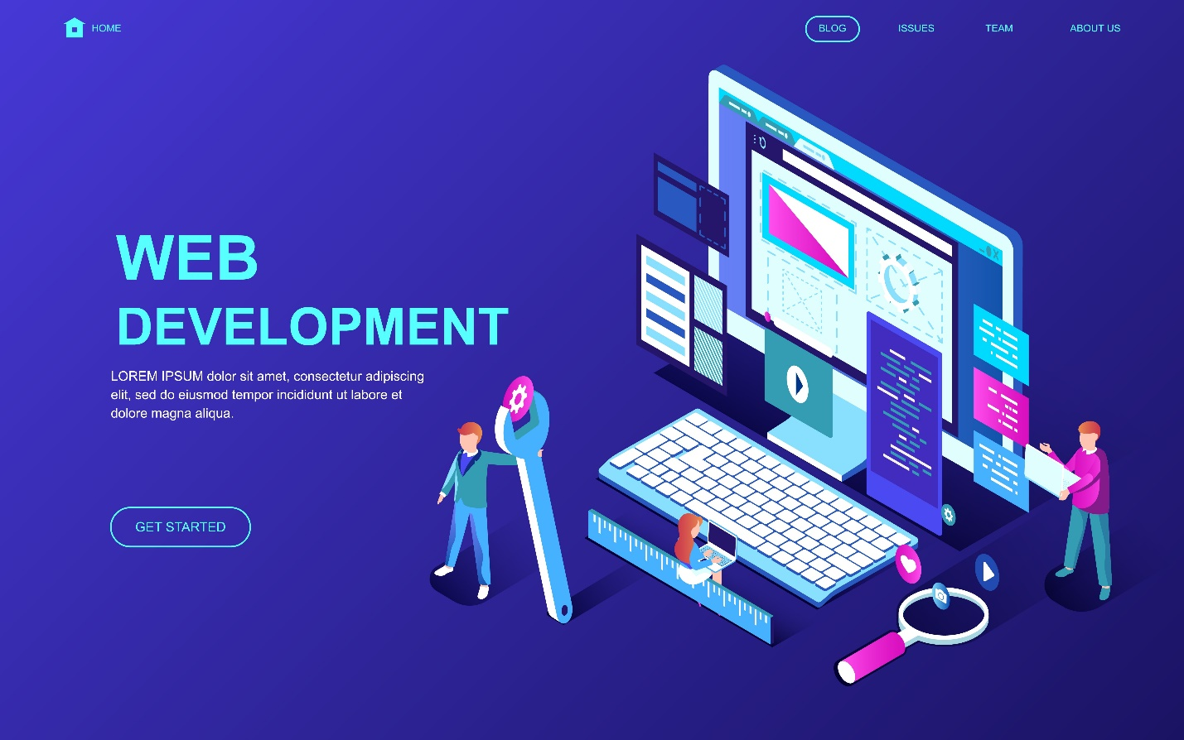

**Made by: Georgi Zhizgov, S2-CB06**

# Introduction

In week one we discussed the specifics of HTML and CSS and how to use them in a proper way. We were assigned to create a website based on our own preference and should meet the following requirements:

* Must have pages for registered users
* Must revolves around a type of content which is dynamically loaded from a MySQL Database.
* Must make use of a GitLab repository from Fontys ICT.

- Cannot be the web application required for the module PRJ.

- Cannot make use of layout frameworks such as Bootstrap.

- Cannot make use of an ORM such as Entity Framework.

# Description

In the next five weeks I am obliged to create a website, based on HTML and CSS, which will be used for online shopping for wrestling properties. There will be three categories- wrestling shoes, clothes and accessories. The audience of this web shop will be the wrestling community in Europe.

What is more there will be two main type of users- Admin, the one who keeps track of orders, updates products, in general the Admin is the person (it may be people depend on the capacity and work of the website) who manage the whole business and Client, the visitor of the website who would like to take a look of the items or even buy items.

A Client can:

* See the content of the page;
* Add items to the cart;
* Remove items from the cart;
* Search for current item;
* Register;
* Log in;
* Log out;

An Admin can:

* See the content of the page;
* Search for current item;
* Log in;
* Log out;
* Create items;
* Remove items;

# Sitemap

What can users access, represented by this sitemap

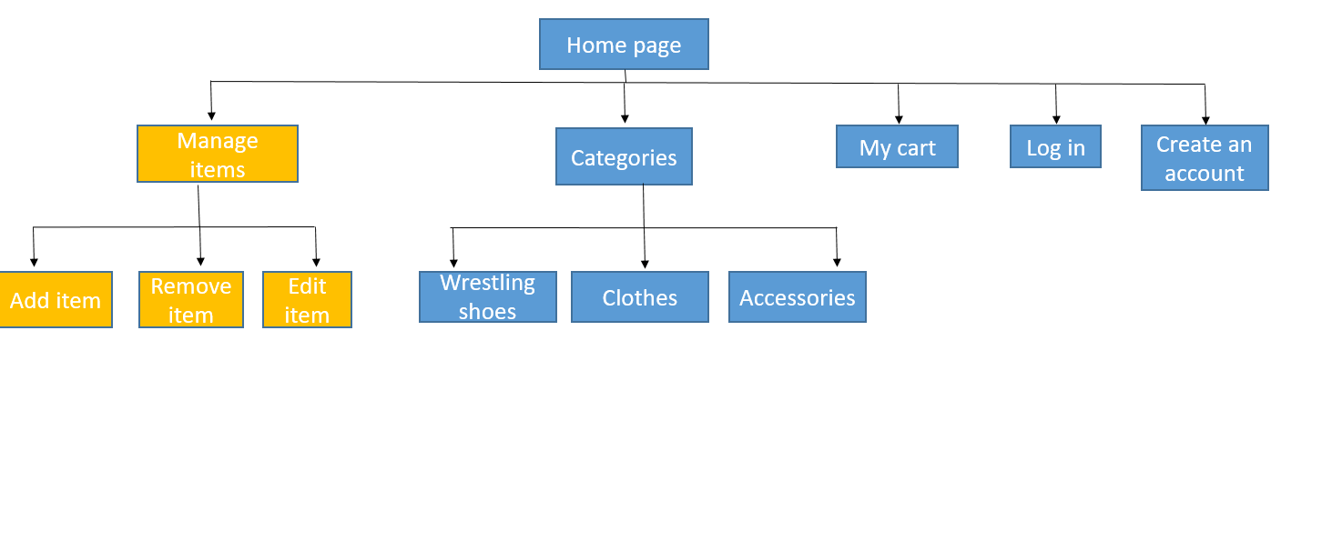

The blue stands for the Client (basic user).

The yellow stands for the Admin (who also has access to the blue part).

# Wireframe

Basic example of the initial design of the website’s home page

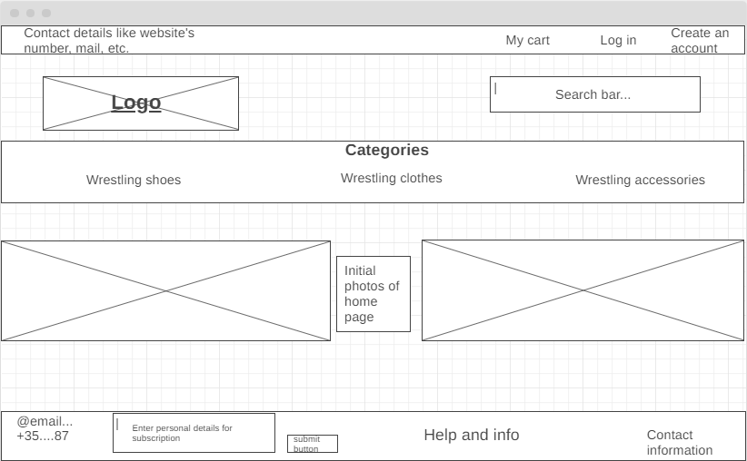

# References

Git repository - https://git.fhict.nl/I463263/wad-s2_assignment.git